**1. 모듈명: 범주형자료분석 – 분할표분석**

**2. 디버깅 일시: 20171123**

**3. 사용데이터: birth_clean**

**4. UI 캡쳐:**

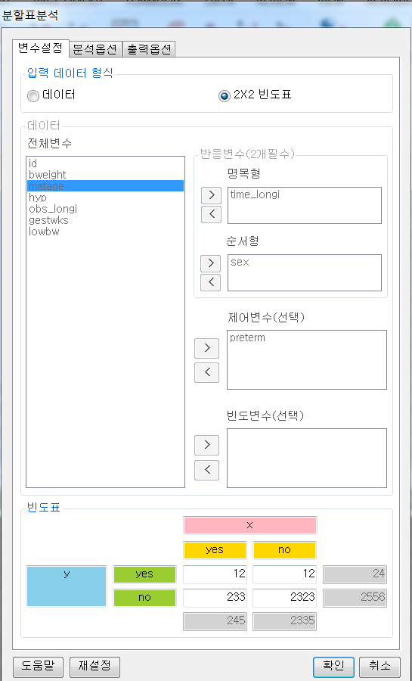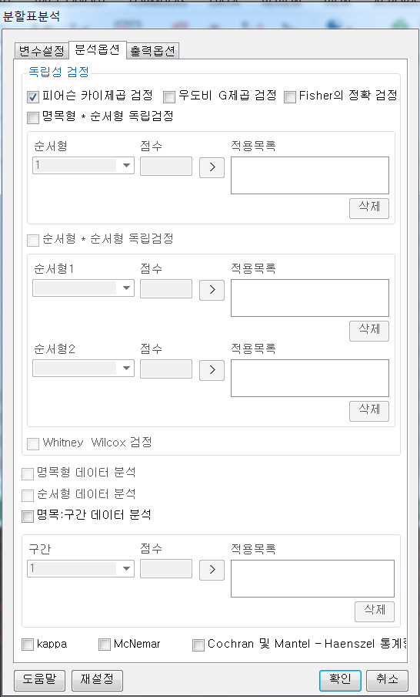

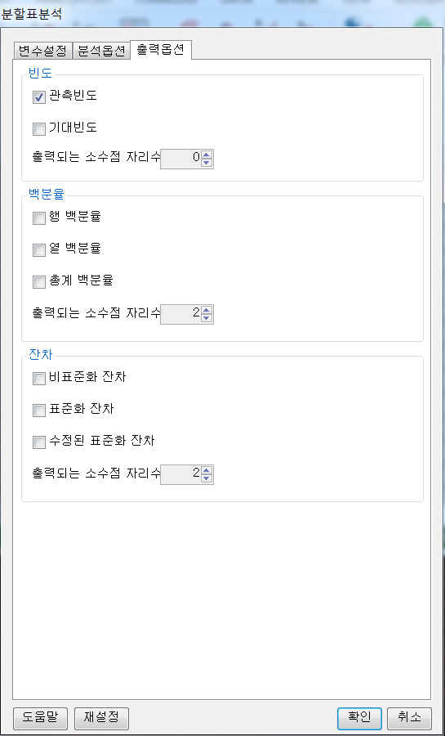

**5. 로그창:**

>REx_ContinTabAnal(data.frame("yes"=c(12,233,245),"no"=c(12,2323,2335),"tot"=c(24,2556,NA),row.names=c("yes","no","tot")), freq.table=TRUE, row.sum=TRUE, col.sum=TRUE, row.var.name=TRUE, col.var.name=TRUE, chsq.test=TRUE, likelihood.test=FALSE, fisher.exact.test=FALSE, nominal.order.test=FALSE, lbl.test=FALSE, whitney.wilcox.test=FALSE, contingency.coefficient=FALSE, phi=FALSE, cramerV=FALSE, lambda=FALSE, uncertainty.coefficient=FALSE, pearson.cor=FALSE, spearman.cor=FALSE, gamma=FALSE, somerD=FALSE, kendall.taub=FALSE, kendall.tauc=FALSE, eta=FALSE, kappa=FALSE, mcnemar=FALSE, cmh.test=FALSE, freq.obs=TRUE, freq.exp=FALSE, freq.dec=0, percent.row=FALSE, percent.col=FALSE, percent.tl=FALSE, percent.dec=2, res.unstnd=FALSE, res.stnd=FALSE, res.adj=FALSE, res.dec=2);

**ERROR! argument must be coercible to non-negative integer**

**6. 에러메세지:**

변수설정 탭에서 2X2 빈도표를 선택하고, 하단 빈도표에 직접 숫자 입력하면 발생하는 에러로 보임.

빈도표에 음수 입력해도 같은 에러가 발생됨.

빈도표이므로 음수 입력 방지할 필요도 있어보임

**1. 모듈명: 범주형자료분석 – 분할표분석**

**2. 디버깅 일시: 20171123**

**3. 사용데이터: birth_clean**

**4. UI 캡쳐:**

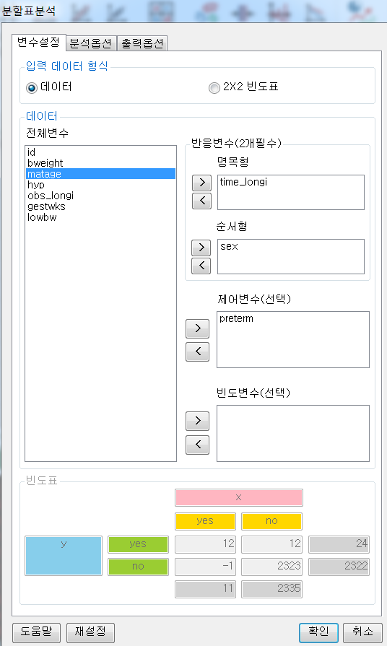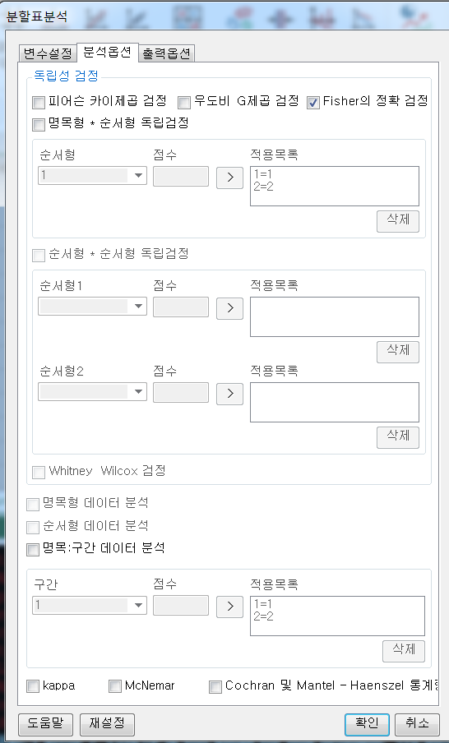

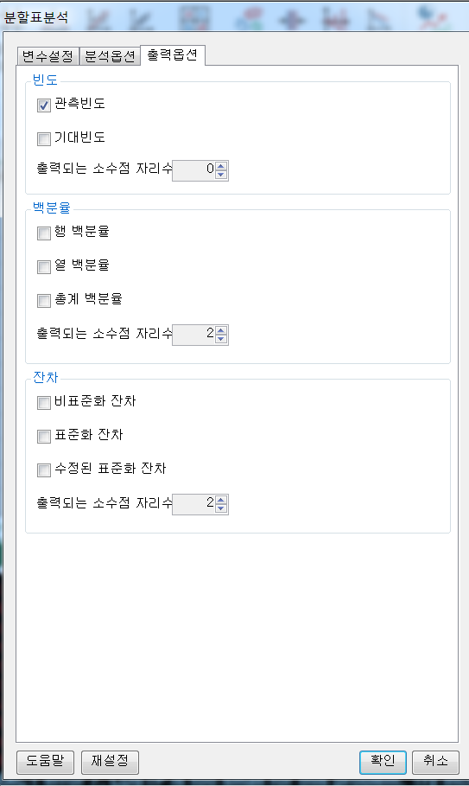

**5. 로그창:**

> REx_ContinTabAnal(df20171123131836, freq.table=FALSE, row.sum=FALSE, col.sum=FALSE, row.var.name=FALSE, col.var.name=FALSE, x='time_longi', y='sex', adj.var='preterm', chsq.test=FALSE, likelihood.test=FALSE, fisher.exact.test=TRUE, nominal.order.test=FALSE, lbl.test=FALSE, whitney.wilcox.test=FALSE, contingency.coefficient=FALSE, phi=FALSE, cramerV=FALSE, lambda=FALSE, uncertainty.coefficient=FALSE, pearson.cor=FALSE, spearman.cor=FALSE, gamma=FALSE, somerD=FALSE, kendall.taub=FALSE, kendall.tauc=FALSE, eta=FALSE, kappa=FALSE, mcnemar=FALSE, cmh.test=FALSE, freq.obs=TRUE, freq.exp=FALSE, freq.dec=0, percent.row=FALSE, percent.col=FALSE, percent.tl=FALSE, percent.dec=2, res.unstnd=FALSE, res.stnd=FALSE, res.adj=FALSE, res.dec=2);

**ERROR! FEXACT error 7. LDSTP is too small for this problem. Try increasing the size of the workspace.**

**6. 에러메세지:**

**분석옵션** 탭에서 독립성검정 - **Fisher의 정확 검정** 옵션에 체크하는 경우 발생하는 에러. **Fisher의 정확 검정** 옵션을 해제하고, **명목형+순서형 독립검정** 옵션을 체크할 경우 아래와 같은 다른 에러 발생

> REx_ContinTabAnal(df20171123131836, freq.table=FALSE, row.sum=FALSE, col.sum=FALSE, row.var.name=FALSE, col.var.name=FALSE, x='time_longi', y='sex', adj.var='preterm', chsq.test=FALSE, likelihood.test=FALSE, fisher.exact.test=FALSE, nominal.order.test=TRUE, cmh.y.score=list('1'=1,'2'=2), lbl.test=FALSE, whitney.wilcox.test=FALSE, contingency.coefficient=FALSE, phi=FALSE, cramerV=FALSE, lambda=FALSE, uncertainty.coefficient=FALSE, pearson.cor=FALSE, spearman.cor=FALSE, gamma=FALSE, somerD=FALSE, kendall.taub=FALSE, kendall.tauc=FALSE, eta=FALSE, kappa=FALSE, mcnemar=FALSE, cmh.test=FALSE, freq.obs=TRUE, freq.exp=FALSE, freq.dec=0, percent.row=FALSE, percent.col=FALSE, percent.tl=FALSE, percent.dec=2, res.unstnd=FALSE, res.stnd=FALSE, res.adj=FALSE, res.dec=2);

**ERROR! object 'war.msg1' not found**

분석 옵션 탭에서 아래와 같이 모두 체크 해제하고, 맨 아래 옵션 중

**kappa** / **MCmar /** **Cochran 및 Matel–Haenszel 통계량** 선택해도 에러 발생

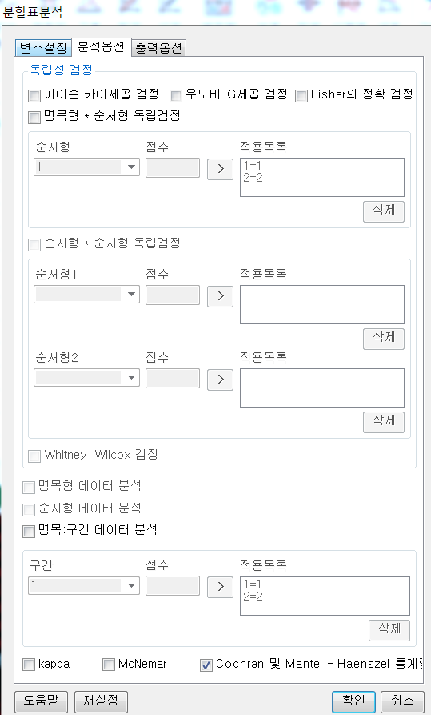

**kappa** 옵션 체크시

> REx_ContinTabAnal(df20171123131836, freq.table=FALSE, row.sum=FALSE, col.sum=FALSE, row.var.name=FALSE, col.var.name=FALSE, x='time_longi', y='sex', adj.var='preterm', chsq.test=FALSE, likelihood.test=FALSE, fisher.exact.test=FALSE, nominal.order.test=FALSE, lbl.test=FALSE, whitney.wilcox.test=FALSE, contingency.coefficient=FALSE, phi=FALSE, cramerV=FALSE, lambda=FALSE, uncertainty.coefficient=FALSE, pearson.cor=FALSE, spearman.cor=FALSE, gamma=FALSE, somerD=FALSE, kendall.taub=FALSE, kendall.tauc=FALSE, eta=FALSE, kappa=TRUE, mcnemar=FALSE, cmh.test=FALSE, freq.obs=FALSE, freq.exp=FALSE, freq.dec=0, percent.row=FALSE, percent.col=FALSE, percent.tl=FALSE, percent.dec=2, res.unstnd=FALSE, res.stnd=FALSE, res.adj=FALSE, res.dec=2);

**ERROR! non-conformable arguments**

**MCmar** 옵션 체크시

> REx_ContinTabAnal(df20171123131836, freq.table=FALSE, row.sum=FALSE, col.sum=FALSE, row.var.name=FALSE, col.var.name=FALSE, x='time_longi', y='sex', adj.var='preterm', chsq.test=FALSE, likelihood.test=FALSE, fisher.exact.test=FALSE, nominal.order.test=FALSE, lbl.test=FALSE, whitney.wilcox.test=FALSE, contingency.coefficient=FALSE, phi=FALSE, cramerV=FALSE, lambda=FALSE, uncertainty.coefficient=FALSE, pearson.cor=FALSE, spearman.cor=FALSE, gamma=FALSE, somerD=FALSE, kendall.taub=FALSE, kendall.tauc=FALSE, eta=FALSE, kappa=FALSE, mcnemar=TRUE, cmh.test=FALSE, freq.obs=TRUE, freq.exp=FALSE, freq.dec=0, percent.row=FALSE, percent.col=FALSE, percent.tl=FALSE, percent.dec=2, res.unstnd=FALSE, res.stnd=FALSE, res.adj=FALSE, res.dec=2);

**ERROR! 'x' must be square with at least two rows and columns**

**Cochran 및 Matel – Haenszel 통계량** 옵션 체크시

> REx_ContinTabAnal(df20171123131836, freq.table=FALSE, row.sum=FALSE, col.sum=FALSE, row.var.name=FALSE, col.var.name=FALSE, x='time_longi', y='sex', adj.var='preterm', chsq.test=FALSE, likelihood.test=FALSE, fisher.exact.test=FALSE, nominal.order.test=FALSE, lbl.test=FALSE, whitney.wilcox.test=FALSE, contingency.coefficient=FALSE, phi=FALSE, cramerV=FALSE, lambda=FALSE, uncertainty.coefficient=FALSE, pearson.cor=FALSE, spearman.cor=FALSE, gamma=FALSE, somerD=FALSE, kendall.taub=FALSE, kendall.tauc=FALSE, eta=FALSE, kappa=FALSE, mcnemar=FALSE, cmh.test=TRUE, freq.obs=TRUE, freq.exp=FALSE, freq.dec=0, percent.row=FALSE, percent.col=FALSE, percent.tl=FALSE, percent.dec=2, res.unstnd=FALSE, res.stnd=FALSE, res.adj=FALSE, res.dec=2);

**ERROR! Lapack routine dgesv: system is exactly singular: U[1,1] = 0**